Chip-Level Design of a Hardware Root-of-Trust for Firmware Authentication

Block Diagram of a Hardware ROT
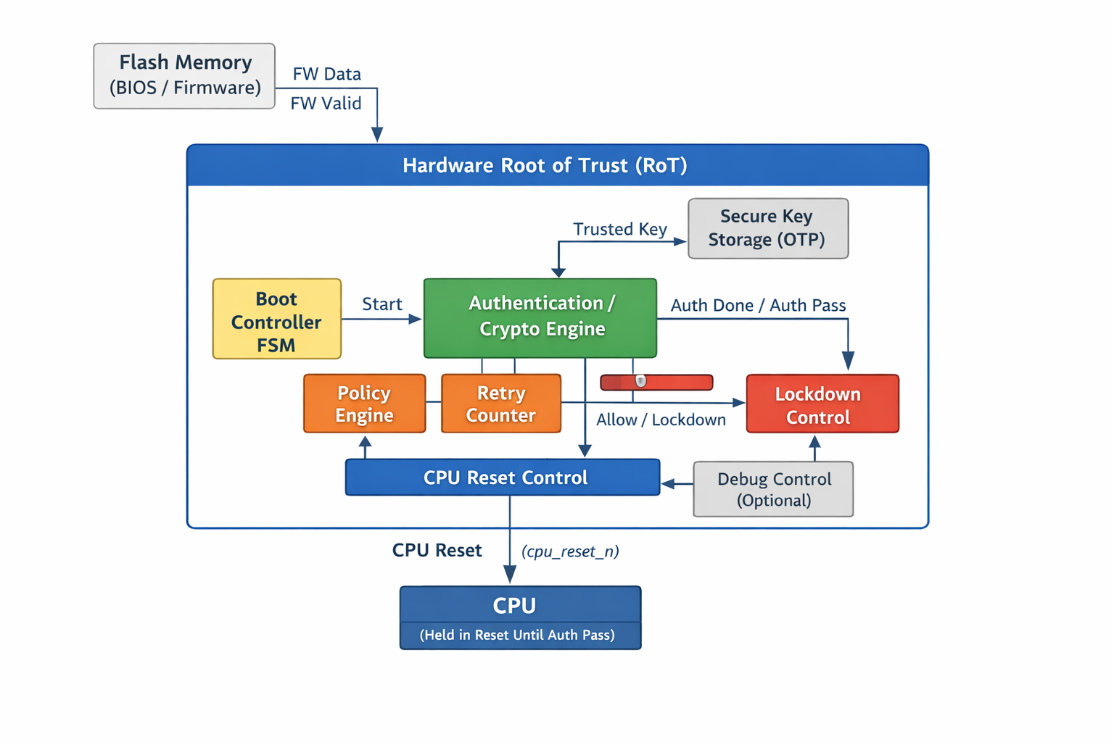
Complete Module-Level and Pin-to-Pin Design Document

1. Introduction
This document describes the complete Hardware Root-of-Trust (RoT) architecture implemented for secure boot, operating strictly before CPU execution. The RoT ensures that only authenticated firmware (BIOS/bootloader) stored in flash memory is allowed to execute by holding the CPU in reset until verification succeeds.
This design is:
- Hardware-enforced (no software dependency)
- Deterministic and fail-safe
- Suitable for SoC secure boot reference implementations

2. Top-Level Module: rot_top
What it is
rot_top is the integration wrapper for the entire Root-of-Trust IP. It defines the security boundary of the RoT and exposes only minimal, safe control signals to the rest of the SoC.
Role
- Instantiates and connects all RoT submodules
- Routes firmware data and control signals
- Exposes CPU reset and boot status
- Prevents any direct external access to secure internals
Pin Description
Inputs
- clk : System clock used by RoT logic
- rst_n : Global reset (active low)
- boot_req : Indicates a boot request after power-on
- fw_data [N-1:0] : Firmware data stream from flash controller
- fw_valid : Indicates valid firmware data
- fw_last : Indicates last firmware word (optional)
Outputs
- cpu_reset_n : Controls CPU reset (active low)
- boot_done : Indicates boot decision completed
- boot_pass : Indicates firmware authentication success
- secure_mode : Indicates system is in secure boot mode
- debug_disable : Disables debug access during secure boot

3. Boot Controller FSM: boot_ctrl_fsm
What it is
A finite state machine that controls the entire secure boot flow. It is the central decision coordinator but does not perform cryptography or access secret keys.
Role
- Enforces strict boot sequencing
- Triggers authentication
- Waits for authentication result
- Commands allow / deny / lockdown actions
FSM States
- FSM_RESET
- FSM_IDLE
- FSM_AUTH_START
- FSM_AUTH_WAIT
- FSM_CHECK_RESULT
- FSM_BOOT_ALLOW
- FSM_BOOT_DENY
- FSM_LOCKDOWN
Pin Description
Inputs
- clk
- rst_n
- boot_req
- auth_done
- auth_pass
- lockdown_req
Outputs
- start_auth : Triggers authentication engine
- boot_done
- boot_pass
- cpu_allow : Allows CPU reset release
- enter_lockdown

4. Authentication Engine: auth_engine
What it is
A hardware authentication block that verifies firmware authenticity using a trusted reference from secure key storage.
Role
- Receives firmware data as a stream
- Computes hash or verifies signature (abstracted)
- Compares against trusted key/hash
- Reports pass/fail result
Pin Description
Inputs
- clk
- rst_n
- start_auth
- fw_data [N-1:0]
- fw_valid
- fw_last
- trusted_key [K-1:0]
Outputs
- auth_done : Authentication complete
- auth_pass : Authentication success
Notes
- Cryptographic strength is abstracted
- Focus is on functional correctness and control flow

5. Secure Key Storage: secure_key_storage
What it is
A protected, immutable storage block holding trusted root material such as public keys or golden hashes.
Role
- Acts as trust anchor
- Prevents software or external access
- Supplies keys only to auth engine
Pin Description
Inputs
- clk
- rst_n
Outputs
- trusted_key [K-1:0]
Properties
- No write interface
- OTP / ROM modeled
- Only readable internally

6. Firmware Data Interface: fw_data_if
What it is
Logical interface between external flash controller and RoT.
Role
- Supplies firmware data to authentication engine
- Decouples RoT from flash implementation
Signals
- fw_data
- fw_valid
- fw_last

7. Policy Engine: policy_engine
What it is
A rule-evaluation block that decides final boot action based on authentication result and system policy.
Role
- Interprets auth results
- Applies retry limits
- Requests lockdown if needed
Pin Description
Inputs
- auth_done
- auth_pass
- retry_count
Outputs
- policy_allow
- policy_deny
- lockdown_req

8. Retry Counter: retry_counter
What it is
A security counter that limits repeated authentication attempts.
Role
- Prevents brute-force attacks
- Triggers lockdown after threshold
Pin Description
Inputs
- clk
- rst_n
- auth_fail
Outputs
- retry_count
- retry_exceeded

9. Lockdown Controller: lockdown_ctrl
What it is
A fail-safe security module that enforces permanent denial on critical failures.
Role
- Overrides all boot logic
- Forces CPU reset
- Disables debug permanently
Pin Description
Inputs
- lockdown_req
Outputs
- lockdown_active

10. CPU Reset Control: cpu_reset_ctrl
What it is
Final enforcement point controlling CPU execution.
Role
- Holds CPU in reset until secure boot passes
- Reacts immediately to failures
Pin Description
Inputs
- cpu_allow
- lockdown_active
Outputs
- cpu_reset_n

11. Debug Control (Optional): debug_ctrl
What it is
Security block that controls debug access during secure boot.
Role
- Prevents debug-based attacks
- Locks debug permanently on failure
Pin Description
Inputs
- secure_mode
- lockdown_active
Outputs
- debug_disable

12. Summary
This RoT design:
- Operates strictly before CPU execution
- Enforces secure boot via hardware FSM
- Separates control, cryptography, and policy
- Is extensible and synthesizable
This document serves as a complete design reference for implementation, verification, and academic publication.

